***Chemistry***

**18: Representative Metals, Metalloids, and Nonmetals**

**18.8: Occurrence, Preparation, and Properties of Phosphorus**

67. Write the Lewis structure for each of the following. You may wish to review the chapter on chemical bonding and molecular geometry.

(a) PH3

(b) 

(c) P2H4

(d) 

(e) PF5

Solution

(a)

;

(b)

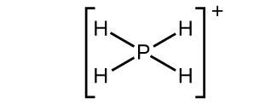;

(c)

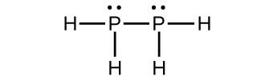;

(d)

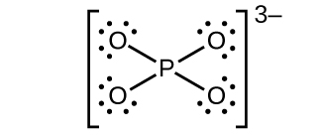;

(e)

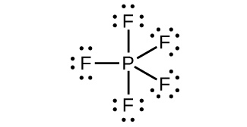

69. Complete and balance each of the following chemical equations. (In some cases, there may be more than one correct answer.)

(a) 

(b) 

(c) 

(d) 

(e) 

(f) 

Solution

(a); (b); (c); (d)  or; (e)  or; (f) 

71. What volume of 0.200 *M* NaOH is necessary to neutralize the solution produced by dissolving 2.00 g of PCl3 is an excess of water? Note that when H3PO3 is titrated under these conditions, only one proton of the acid molecule reacts.

Solution



From the first equation there are 4 moles of acid (one from H3PO3 and three from HCl) generated from each mole of PCl3:



mol = 4(0.0145635 mol PCl3) = 0.05825 mol (HCl + H3PO3) = 0.05825 mol 



73. How many tons of Ca3(PO4)2 are necessary to prepare 5.0 tons of phosphorus if the yield is 90%?

Solution

The equation is:



At 90 percent yield,  is required.

75. Draw the Lewis structures and describe the geometry for the following:

(a) 

(b) PF5

(c) 

(d) POF3

Solution

(a)

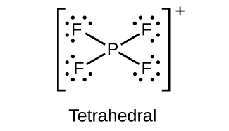;

(b)

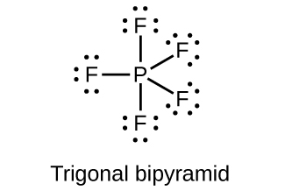;

(c)

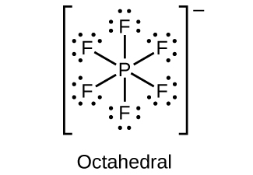;

(d)

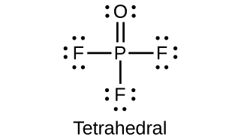

77. Assign an oxidation state to phosphorus in each of the following:

(a) NaH2PO3

(b) PF5

(c) P4O6

(d) K3PO4

(e) Na3P

(f) Na4P2O7

Solution

(a) P = 3+; (b) P = 5+; (c) P = 3+; (d) P = 5+; (e) P = 3–; (f) P = 5+

This resource file is copyright 2015, Rice University. All Rights Reserved.